Kickstarter Analysis

Starting a new business or getting an idea off the ground is the hard work even in the best of economies and circumstances. One needs not only passion and knowledge, but also capital to get their dream to come to life (and a bit of luck). Kickstarter is a way to “kickstart” one’s idea and help raise the capital you need to get your idea off the ground. To be successful in Kickstarter, there are a few ideas to consider when launching a project. This report and corresponding spreadsheet analyzes 4,000 past Kickstarter projects over a range of 8 years to determine any trends or correlations to help determine what factors play a part in launching a successful Kickstarter project. This report will also explain the methods that were used to arrive at the conclusions and recommendation.

In analyzing the presented the dataset, I ran some formulas and created some charts to determine correlations and trends.

I created two pivot tables and charts:

* Pivot 1 – comparing all categories of projects to the “state” of the project (i.e, “successful”, “failed”, “canceled”).
* A screenshot of a computer

  Description automatically generatedPivot 2 – comparing all sub-categories of projects to the “state” of the project.

Pivot 1

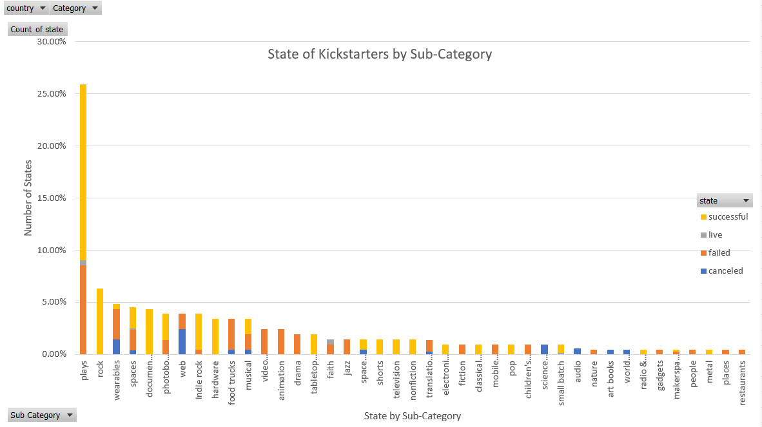

Pivot 2

While conducting this analysis, I came to the following conclusions:

* The arts (theater, music, and film & video) have the most projects started and have the highest success rate as well (theater -60%, music – 77%, film & video – 57%).
* In the film & video category, documentaries were the most popular, followed by animation, each with 100% success rate.
* Rock music was had the most successful (100% success) from the music category, followed by indie music.
* Plays took the win with number of projects and success rate (65%).

I also created a pivot table and line graph looking for seasonal trends. My analysis determined:

* More projects are started and succeeded in the spring and summer months.
* More failures occur in the colder fall and winter months.

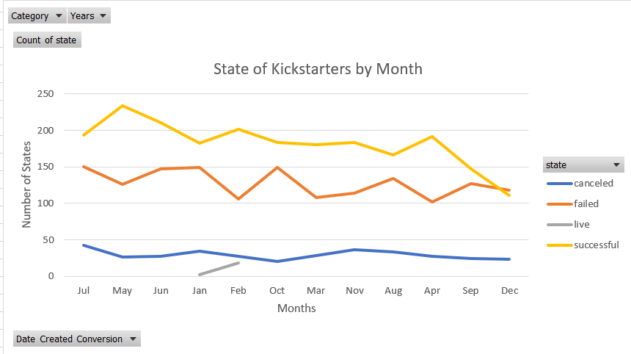

These analyses indicate that launching a project focused on the arts in the warmer months have a higher probability of being successful.

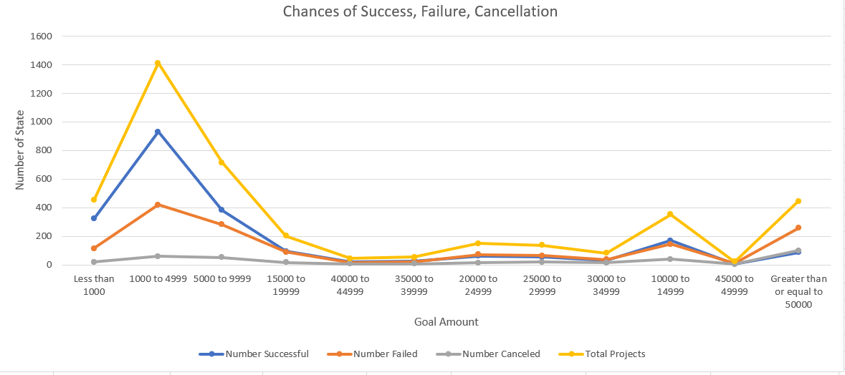I also compared the monetary goal each Kickstarter project had with the success or failure of the project. The data concludes that the higher the goal amount, the higher percentage of failure. I ran COUNTIFS statements to determine the mount of successes, failures, and canceled projects for different ranges of dollar amounts. This analysis found the highest percentage of success is found in the lower than $1,000” range. As the goal amount increases, so does the rate of failures.

Finally, I conducted a statistical analysis of successful and unsuccessful businesses and the amount of backers. I used formulas to determine the mean, median, mix, max, variance, and standard deviation of both. From this analysis I concluded that successful Kickstarters have, on average, more backers than unsuccessful ones. There were some outliers in our dataset, however, which skewed the mean of these numbers. Therefore, the median of 62(successful) and 3(unsuccessful) provides a more meaningful summarization. This analysis also revealed that there is a bigger variability with successful campaigns. This makes sense because a lot of the unsuccessful projects had little-to-no backers, so there were more numbers to work with for successful projects.

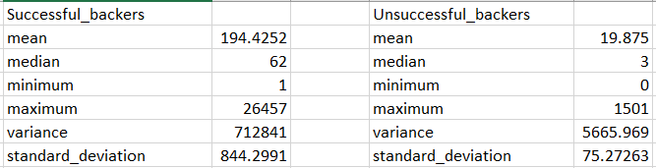

There are a couple of limitations with the dataset we are analyzing that should be addressed. One of the limitations is that the dataset is from almost 5 years ago (2017), so the numbers and trends could be different in 2021. There is also a limited sample size. While 4,000 projects is a pretty large amount, in comparison to the over 300,000 projects there are on Kickstarter, that is only a sampling of 1.3% of total projects.

In conclusion, based on the analysis conducted, I recommend a Kickstarter project focusing on the arts, with music being the top choice, specifically rock music. I also recommend launching the project in the warmer, summer months, with a lower monetary goal. By using these recommendations and getting as many backers as you can, the data reveals, you will have the highest chance of success with your Kickstarter project.